***CONTACT***

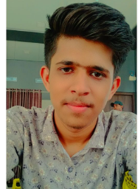

contact.pngPHONE NUMBER: +91 7709487326 gmail.pngE-MAIL: [khatiktoheed@gmail.com](mailto:khatiktoheed@gmail.com)

*location.png* Khatik Wada Dharangaon Dist Jalgaon (425105)

HOBBIES: Playing Physical Games Like Circket,Vollyball,Kabbadi. & Studying New Things To Increase My Abilities

FATHER’S NAME: MUSTAQUE SHAIKH YUSUF KHATIK

DATE OF BIRTH: 14-09-2001

MARITAL STATUS : UNMARRIED

FRONT END:

DTP :

C&C++ :

DBMS :

MS-OFFICE:

Educational Details :

***address***

JUNIOR COLLGE

SCHOOL

Anglo Urdu High School & Junior College ,Dharangaon

Date Of Admission: 17/06/2011

Date Of Leaving School: 31/05/2017

I Passed Out 10th  Board Exam From This College.

Arts, Commerce And Science College Dharangaon

Dist.Jalgaon Dist Jalgaon

Date Of Admission: 06/07/2017

Date Of Leaving School: 31/05/2019

I Passed Out 12th  Board Exam From This College.

***Other additional detail***

GRADUATE

Kbc NMU University Jalgaon Maharashtra.

Date Of Admission: 06/07/2019

Date Of Leaving School: 31/05/2022

I Completed My Graduation In B.Sc.IT From This University. University.

OBJECTIVE

***SKILLS***